UNIVERSITY OF GLASGOW

Department of Physics and Astronomy Dr Martin Hendry
EXCOS 1X 2004-2005 Room 607, ext 5685
martin@astro.gla.ac.uk

Exploring the Sky

Lecture 8: The Ptolemaic Universe and the Copernican Revolution

Early Greek Astronomy

Although the Greeks inherited many astronomical ideas from Babylonia and Egypt, Greek astronomers were the first to try to understand the Universe in a scientific way. Thales (624 – 547 BC) taught that the Universe was rational, capable of being understood by the human mind. Pythagoras (570 – 500 BC) observed that nature seemed to be governed by mathematical relations and proposed that the movement of celestial bodies followed the same mathematical rules as musical notes – the harmony of the spheres. Plato (428 – 347 BC), although not an astronomer, influenced astronomical ideas for 2000 years, arguing that reality is only a distorted shadow of a perfect form. The most perfect form in nature was the circle; hence, Plato reasoned, all celestial motions must consist of combinations of circular motions.

Pythagoras taught that the Earth is a sphere, and the Sun, Moon and planets are divine, perfect spheres moving in perfect circles. Eudoxus (409 – 356 BC) constructed a system of 27 nested spheres, all rotating at different rates, to explain the various celestial motions. Aristotle (384 – 322 BC) proposed that the Universe was divided into two parts: the corrupt and changeable Earth, and the perfect and immutable heavens. Aristotle’s Universe (like that of most of his predecessors) was geocentric – i.e. with the Earth immobile at the centre. He extended Eudoxus’ system to 56 crystalline spheres, with the lowest sphere – that of the Moon – marking the boundary between imperfection and perfection.

The geocentric view was not universally held. Aristarchus (310 – 230 BC) proposed that the Earth revolved around the Sun, based on clever (and essentially correct!) geometrical arguments, but his ideas never took root – because they disagreed with Aristotle’s theory, and because the fixed stars showed no measurable parallax shift. (See also Lecture 2).

As observations of the positions of the Sun, Moon and planets became more accurate, Greek astronomers realised that Aristotle’s model of the Earth sitting at the exact centre of the system of crystal spheres was inadequate. Hipparchus (160 – 127 BC) retained the crystal spheres and circular motion but placed the Earth a little off centre. However, this model was unable to explain retrograde motion: the observed fact that the planets would sometimes loop back on themselves with respect to the fixed stars (see Figure 1).

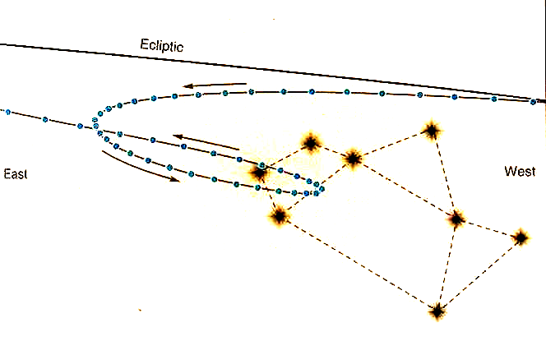
Ecliptic
Figure 1: Retrograde motion of the planet Mars
The Ptolemaic Universe

Two centuries after Hipparchus, Ptolemy (90 – 168 AD) proposed a model that appeared able to explain the apparent motion of the known planets, including their occasional retrograde loops. In the geocentric Ptolemaic Universe the planets moved along epicycles: small circles which themselves moved along larger circles (known as deferents). Ptolemy could adjust the size of these epicycles and the rate at which they moved along their deferents until he matched the apparent motion of the planets as seen from the Earth. At certain times, this motion would appear retrograde from the Earth as the planet was moving along the epicycle in the opposite direction to the epicycle’s motion along the deferent. As a final adjustment to improve the match, he could also place the Earth slightly off-centre in the deferent circle – just as in Hipparchus’ model.

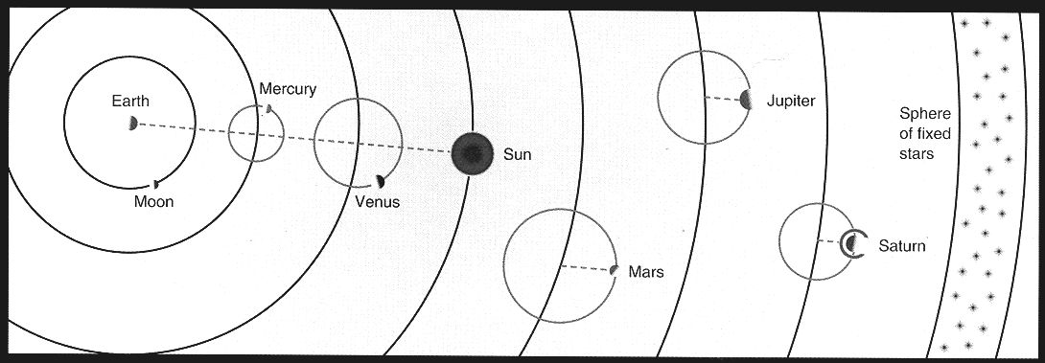

Figure 2: The Ptolemaic Universe

Ptolemy published his model about AD 140, in a book now known as the Almagest. It was not particularly simple – one might say that the epicycles made it inelegant – but when it was published it was extremely successful at predicting the positions of the Sun, Moon and planets.

The Copernican Revolution

As the centuries passed, the positions of the Sun, Moon and planets predicted by Ptolemy’s model began to diverge from their observed positions. These errors grew steadily with time and prompted Arabian – and later European – astronomers to update the model, adding extra epicycles where required. These updates always proved merely temporary ‘fixes’, however. Consequently, by the mid sixteenth century, Ptolemy’s model had become a very poor predictor of the positions of the planets. Nevertheless, because it was broadly consistent with Aristotelian philosophy (which the Church had adopted as dogma) the Ptolemaic Universe remained the accepted model for almost all astronomers – and, for example, had been the standard view taught in astronomy lectures at Glasgow University since 1451. Any astronomer who questioned it risked being accused of heresy.

This may partly explain why the Polish astronomer Nicolaus Copernicus (1473 – 1543 AD) waited until very nearly the end of his life to publish his book De Revolutionibus Orbium Coelestium (On the Revolution of the Celestial Orbs), in which he proposed a heliocentric model: the Sun, and not the Earth, lay at the centre of the Universe and the Earth – together with all the other planets – followed a circular orbit around the Sun. Copernicus (and others) had been discussing the idea of a heliocentric model informally for many years before, but the prospect of being burned at the stake as a heretic had previously deterred him from going ‘on the record’.
The ideas of Copernicus were certainly controversial (indeed it is the name of his book which is the origin of the word revolutionary), but at first De Revolutionibus was not widely read, and even less widely understood, and the Church did not officially condemn the book until 1616 – long after Copernicus’ death and after Galileo had entered the scene.

It is important to realise that the Copernican Universe was also totally incorrect in many important respects. As we will see in Lecture 9, the planets do not move on circular orbits around the Sun. Consequently, predictions of planetary positions in Copernicus’ model were not really any more accurate than in the Ptolemaic Universe. Also, we now know that the Sun is not the centre of the Universe, but is just one ordinary star among about a hundred billion others in the Milky May galaxy, so that the ‘sphere of fixed stars’ is just an optical illusion. Moreover, Big Bang cosmology tells us that there is no centre to the Universe – at least not in the sense understood in the worldview of both Ptolemy and Copernicus (see EXCOS1Y Lectures).

The success of the Copernican model is not due to its details, but rather its central idea – which is correct: the Earth goes round the Sun, rather than the Sun goes round the Earth. In addition, the Copernican model is widely seen as being simpler and more elegant (an important criterion in assessing modern scientific theories). The fact that Mercury and Venus always appear in the sky close to the Sun is simply because their orbits lie inside that of the Earth. (In the Ptolemaic Universe this could only be explained by forcing the epicycles of Mercury and Venus to orbit the Earth at the same rate as the Sun). More importantly, the retrograde motion of e.g. Mars could be very easily explained by the Earth ‘overtaking’ Mars on its orbit – rather like a car overtaking on the inside lane of a roundabout.

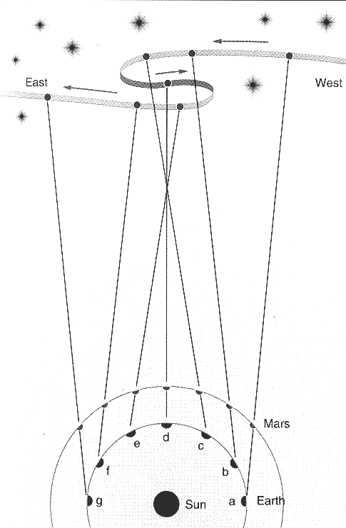

Figure 3: Retrograde Motion explained in the Copernican Model

The Observations of Galileo

Although Copernicus set things moving (quite literally!) towards a scientific revolution, the heliocentric hypothesis finally won out over the geocentric hypothesis thanks to the efforts of one of its greatest defenders: Galileo Galilei (1564 – 1642).

In the autumn of 1609 Galileo used the recently invented telescope to view the night sky, and made a series of groundbreaking discoveries – seeing things which no astronomer had ever seen before. In 1610 he published a short book called Sidereus Nuncius (The Starry Messenger) reporting his findings. Three specific observations contradicted the predictions of the Aristotelian and Ptolemaic Universe:

- The Moon is an imperfect world, with mountains and valleys on its surface just like the Earth. Galileo used the length of the shadows of lunar mountains to calculate their height.

- The Milky Way is made up of countless numbers of stars too faint to see with the naked eye – again conflicting with the Aristotelian view of the perfect heavens.

- Jupiter has four new ‘planets’ circling it – known today as the Galilean Moons.

The observation of Jupiter’s moons was particularly damning for the Aristotelian/Ptolemaic worldview. “The Earth cannot move through space”, critics of the heliocentric view had pointed out, “because the Moon would be left behind”. Yet here was evidence that Jupiter moved through space without leaving its moons behind. Moreover, the Aristotelian philosophy held that all heavenly motions were around the Earth, which remained immobile, yet here was a heavenly motion centred on Jupiter. Again, the order and perfection of the heavens was being challenged.

Galileo’s later observations continued to bolster the case for the heliocentric view. He observed sunspots, showing that even the Sun was not perfect. He also observed that the planet Venus showed phases just like the Moon. This was clear and unequivocal evidence that Venus orbited the Sun and not the Earth (see Figure 4).

Galileo’s work attracted huge controversy and landed him in a great deal of trouble with the Church authorities, as much for the irreverent manner in which he presented his results as for the results themselves. His contribution to the development of astronomy was immense – not just by what he observed but by promoting the idea that observations are a powerful tool for studying the Universe, and that a theory derived from abstract philosophy (e.g. religious doctrine) can be tested – and ruled out – using observations. This idea is absolutely central to the modern scientific method, which owes much to the pioneering efforts of Galileo.

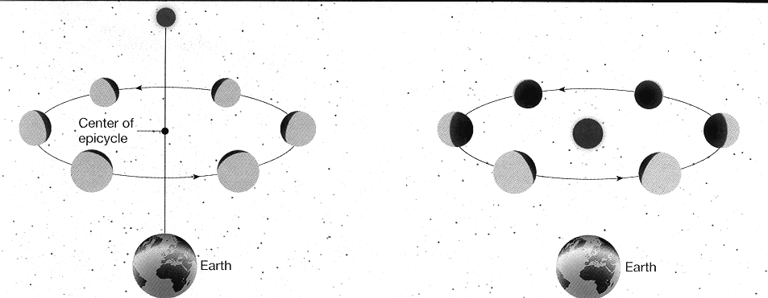

Figure 4: Venus as seen from the Earth in the Ptolemaic and Copernican models

With the benefit of 2000 years of hindsight this is perhaps not too surprising, since Ptolemy had a great deal freedom in choosing his epicycles. In the language of modern physics, Ptolemy’s model had a large number of free parameters with which to fit his data. This should not detract from the fact that Ptolemy’s model was a superb astronomical and mathematical achievement for its time.

