UNIVERSITY OF GLASGOW

Department of Physics and Astronomy Dr Martin Hendry
EXCOS 1X 2004-2005 Room 607, ext 5685
martin@astro.gla.ac.uk

Exploring the Sky

Lecture 6: Celestial Calendars and Clocks

The Sky at Night as a Calendar

The constellations seen in the sky at night provide a crude ‘celestial calendar’, because of the motion of the Sun along the Ecliptic (see Lecture 4). The important point to remember is that, on a given night, the Sun is at its lowest point below the Northern horizon at midnight. Hence those stars with RA values 12 hrs different from the Sun will be at their highest as they cross the Observer’s Meridian in the South at midnight – when the sky is darkest. These ‘midnight constellations’ will change throughout the year, as the RA of the Sun changes. For example:

Date | RA of Sun | RA of ‘midnight constellations’ | Examples
Mar 21st | 0 hrs | 12 hrs | Leo, Ursa Major
Jun 21st | 6 hrs | 18 hrs | Hercules, Lyra
Sep 21st | 12 hrs | 0 hrs | Andromeda, Cassiopeia
Dec 21st | 18 hrs | 6 hrs | Auriga, Orion

The Sun moves Eastwards along the Ecliptic at about 2 hours (= 24 hrs / 12 months) per month, or about 0.5 hours per week. We can use this to work out the most favourable time to view particular constellations or other objects. Suppose, for example, we ask ‘when is the best time of year to see Taurus?’ The RA of Taurus is about $4^{h}{\text{30}}^{m}$. Hence, Taurus will be opposite the Sun (and so highest in the sky at midnight) when the RA of the Sun is ${\text{16}}^{h}{\text{30}}^{m}$. This will be about 3 weeks (= 1.5 hours of RA) before Dec 21st – i.e. on about Dec 1st.

The Sky at Night as a Clock

Ursa Major is a circumpolar constellation as seen from Glasgow. Hence the stars of the Plough are always above the horizon, and the direction of the Pointers can be used to tell the time – rather like the hour hand of a clock – as they rotate through the course of the night at the rate of 15 degrees per hour. (Note, however, that the ‘hour hand’ of the Pointers rotates anti-clockwise).

Astronomical Influences on the Calendar

Study of the language of a wide variety of cultures shows that their references to time and the calendar reveal widespread astronomical connections – this is hardly surprising since the basic time periods of one day and one year are determined by the diurnal and annual motions of the Celestial Sphere. The week of seven days, for example, was established by the Babylonians, with the days being named after the Sun, Moon and 5 (then known) planets: Mercury, Venus, Mars, Jupiter and Saturn. (This connection is less clear in the English names for the days of the week, which have evolved to incorporate characters from Norse legends – e.g. Thursday = Thor’s day – but is much more transparent in e.g. French or Spanish).

The principal astronomical influences on the regulation of our clocks and calendars are the Sun and Moon. We will leave discussion of the Moon until Lecture 7, and consider first the Sun.
The Sun as a Clock

The essence of any reliable timekeeping system is that it should flow evenly. For millennia the daily passage of the Sun across the sky has been the basis of terrestrial timekeeping, using sundials – with the hour of the day indicated by the direction and length of the Sun’s shadow, cast by the central gnomon. However, a basic sundial is not a very accurate timekeeper because the rate of progress of the Sun across the sky varies – due to the slight variations in the Earth-Sun distance – throughout the year. There are times of year when the Sun arrives on the Local Meridian early compared to an evenly running clock, and there are other times of year when it arrives late. Any simple sundial needs correction for this. Astronomers introduced the concept of the Mean Sun: a fictitious Sun the apparent motion of which is at a constant rate throughout the year. Time as measured by the Mean Sun is known as Greenwich Mean Time. The time difference between the fictitious Mean Sun and the real Sun is referred to as the Equation of Time. This time difference varies from –14.25 minutes to +16.25 minutes throughout the year.

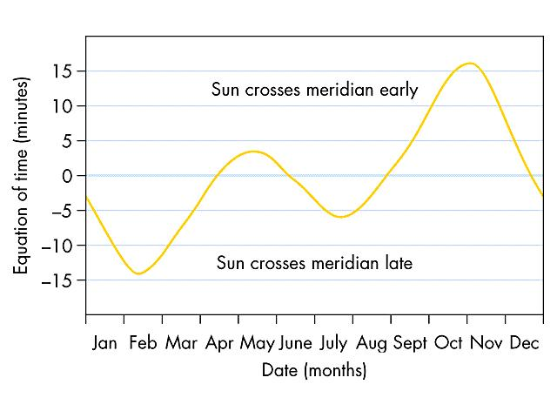
Figure 1: The Equation of Time

Development of the Calendar

Our Western calendar is based on the Sun, but is complicated by the fact that the Earth’s orbital period is not an exact number of days. The approximate period is $\text{365}\frac{1}{4}$ days, which is why we implement a leap year when the year is divisible by four. This regular correction is not completely adequate, however (it is, in fact, an over-correction, as the Earth’s orbital period is – much more accurately – given by $\text{365}\text{.}\text{2422}$days). In our modern system the turn of the century is only a leap year if divisible by 400 (e.g. 2000 was a leap year, but not 1900 or 2100). This calendar scheme is equivalent to assuming an orbital period of $\text{365}\text{.}\text{2425}$days, and is accurate to 1 day in 3323 years.

Our calendar had its origins in ancient Egypt: 12 months of 30 days with 5 days of festival added. This system was subject to a slowly but steadily growing error due to the missing (approximately) $\frac{1}{4}$day per year. In 238 BC Ptolemy III proposed that the ‘leap year error’ should be corrected by adding a 6th festival day every four years; this scheme was finally accepted 200 years later by Julius Caesar and is known as the Julian Calendar, which began on 1 Jan 45 BC.

The Julian Calendar was used throughout Europe until 1582, but by this time the cumulative error caused by assuming an orbital period of $\text{365}\text{.}\text{25}$days had increased to 10 days. In 1582 Pope Gregory XIII decreed that October 4th should be followed by October 15th – thus correcting the error – and thereafter the ‘divisible by 400’ leap year rule should be adopted. This is known as the Gregorian Calendar and is the scheme which we still use today. Protestant areas of Europe did not adopt it until 1752, however, and even then widespread rioting took place as people protested at the ‘theft’ of 10 days from their lives!

