UNIVERSITY OF GLASGOW

Department of Physics and Astronomy Dr Martin Hendry
EXCOS 1X 2004-2005 Room 607, ext 5685
martin@astro.gla.ac.uk

Exploring the Sky

Lecture 5: Celestial Coordinate Systems

The Earth: Latitude and Longitude

The Earth is very nearly a perfect sphere, so any position on its surface can be referenced by two angles as measured from its centre: latitude and longitude (see fig. 1). The N. and S. Poles denote points with latitude $+{\text{90}}^{∘}$ and $−{\text{90}}^{∘}$ respectively, while the Equator is a great circle with latitude $0^{∘}$. Circles of constant latitude are small circles parallel to the Equator. Circles of constant longitude are great circles that run perpendicular to the latitude circles. The so-called Greenwich Meridian is the circle adopted, by international agreement, as the reference that denotes longitude $0^{∘}$. It passes through the original Royal Greenwich Observatory in London.

In astronomy angles are often measured not in decimal units but in the sexagesimal units of degrees, minutes and seconds (of arc), the system introduced by ancient Babylonian astronomers. Thus, in this system, 1 degree = 60 minutes of arc and 1 minute = 60 seconds of arc. As a shorthand, these are denoted by ${}^{∘}\text{'}\text{\} \{}$. Hence the latitude of Iowa City may be written as $+\text{41}\text{.}5^{∘}\text{=+}{\text{41}}^{∘}\text{30}'$, and the longitude of Glasgow is $4^{∘}\text{18}'$W of the Greenwich Meridian.

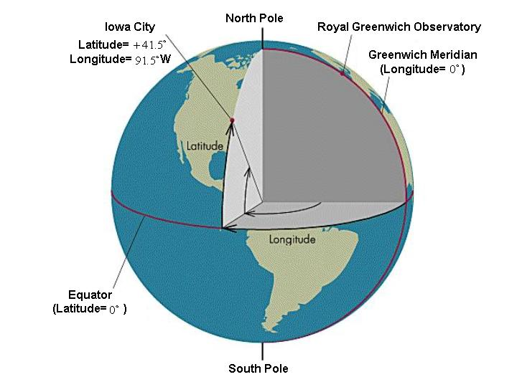

Figure 1: Latitude and Longitude on the Earth

We can work out the effect on the night (and day!) sky of the difference in longitude between Glasgow and Greenwich Meridian. Moving Westwards of the Greenwich Meridian on the surface of the Earth makes the stars appear to move Eastwards. Since the CS appears to rotate from East to West, this means that stars would appear to cross the Meridian in Greenwich before they cross the Meridian in Glasgow – where a observer would have to wait for the CS to ‘rotate’ to catch up with the view seen from Greenwich. We can work out the ‘time lag’ in Glasgow from its longitude. Dividing $4^{∘}\text{18}'$ by ${\text{360}}^{∘}$, we obtain $0\text{.}\text{01194}$. Taking the length of the day as 24 hours = $\text{24}×\text{60}$minutes, this means that the Earth rotates through $4^{∘}\text{18}'$ in $0\text{.}\text{01194}×\text{24}×\text{60}$minutes, or 17 minutes 20 seconds (which we write as ${\text{17}}^{m}{\text{20}}^{s}$). Thus stars cross the Glasgow Meridian ${\text{17}}^{m}{\text{20}}^{s}$ later than the Greenwich Meridian. (Note that this time ‘lag’ also applies to the Sun: if we define local noon as the time when the Sun is due South on the Meridian – and is at its highest altitude – then local noon in Glasgow occurs ${\text{17}}^{m}{\text{20}}^{s}$ after local noon in Greenwich).

We saw in Lecture 2 that the altitude of the Pole Star is equal to the latitude of the observer. We now see that the time of passage of a star (or the Sun) across the local Meridian can be used to measure the observer’s longitude. Thus, to determine one’s position on the Earth, all one requires is an accurate clock. This was the solution proposed by the watchmaker John Harrison to the so-called ‘Longitude Problem’ – posed by the Admiralty and the Royal Society in the 18th Century. Harrison’s invention of ‘H4’ – a watch able to reliably measure the time of meridian passage on long sea voyages – revolutionised sea travel and won him the Longitude Prize in 1763.

Celestial Coordinates: The Equatorial System

There is a direct analogue on the CS of the Earth-based system of latitude and longitude: this system is known as the Equatorial system and the coordinates are known as Declination (Dec) and Right Ascension (RA). The declination of a star is its angle on the CS North or South of the CE; circles of constant Dec are small circles parallel to the CE. Thus Polaris has Dec very close to $+{\text{90}}^{∘}$, while the stars of Orion’s Belt have Dec close to $0^{∘}$. For RA we require a reference point (analogous to the Greenwich Meridian for longitude): this is provided by the Vernal Equinox, the point on the CE where the Sun crosses from South to North – also known as the First Point of Aries. The RA of an object is then measured from the First Point of Aries Eastwards (clockwise) along the CE. Since the timed passage of stars across the local Meridian determines the observer’s longitude, RA (the celestial equivalent of longitude) is generally measured in units of time – i.e. by making a full circle of ${\text{360}}^{0}$ equivalent to ${\text{24}}^{h}$. Since the First Point of Aries appears to move across the sky as the Earth rotates, the angle measured along the CE between it and the local Meridian constantly changes. This angle is known as the Local Sidereal Time.

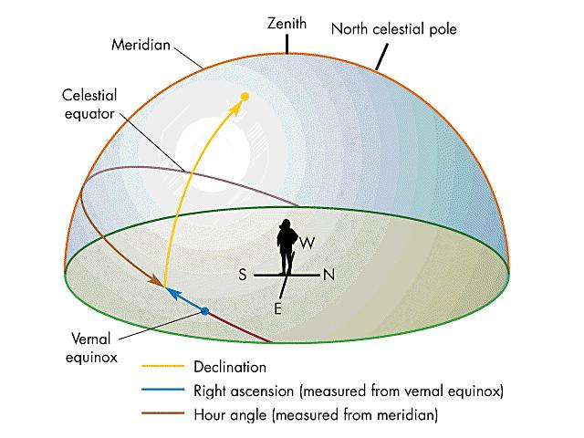

Figure 2: The Equatorial Coordinate System

The RA and Dec of the stars are fixed (ignoring the effect of Precession) but the RA and Dec of the Sun, Moon and planets changes from day to day and from night to night. Their daily values are tabulated in the Astronomical Almanac or can be calculated using astronomical software (e.g. as used in the program ‘Starry Night Backyard’). Knowing the RA and Dec of an object at any given time, and one’s latitude and longitude, an observer can compute the position of the object in the sky at that time using spherical trigonometry – the branch of mathematics which concerns the properties of curved triangles drawn on the surface of a sphere.

