UNIVERSITY OF GLASGOW

Department of Physics and Astronomy Dr Martin Hendry
EXCOS 1X 2004-2005 Room 607, ext 5685
martin@astro.gla.ac.uk

Exploring the Sky

Lecture 4: The Apparent Motion of the Sun and Planets

The Celestial Equator

In addition to the NCP and SCP, another important reference marker in the sky is the Celestial Equator (CE). This is a great circle on the Celestial Sphere (CS) whose circumference is ${\text{90}}^{∘}$ from the NCP and SCP. (A great circle is ‘great’ because its centre is the centre of the CS; any other circle on the CS is called a small circle). The CE is the projection of the Earth’s equator onto the CS (fig. 1). Its position in the sky depends on the observer’s location: for an observer at the North or South poles the CE passes through the local horizon. For an observer situated at the Equator, on the other hand, the CE passes through the E/W points on the horizon and through the zenith (the point directly overhead). The three stars of Orion’s belt lie very close to the CE.

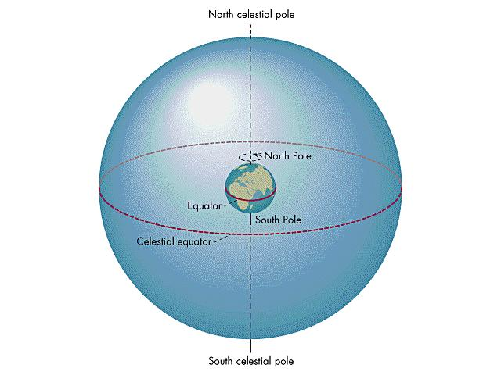

Figure 1: The Celestial Equator

The Effect of Precession

The rising and setting of the stars is explained in terms of the Earth spinning on its axis, which points to the same location in the sky – no matter what time of year. This is not exactly true, as the Earth’s poles ‘migrate’ slightly as a result of shifting ice floes or (less frequently!) earthquakes. There is a much larger shift, however, in the direction of the NCP and SCP, which has important consequences to the long-term positions of stars.

This shift was discovered by Hipparchus, when he compared the positions of bright stars with observations made over the previous few centuries. He found that the position of the NCP and the First Point of Aries (see below) had moved noticeably over a few hundred years. Hipparchus had discovered Precession: the ‘wobbling’ of the Earth on its axis – similar to the wobbling motion of a gyroscope or a spinning top. Precession happens because the Earth is almost but not quite a perfect sphere. The gravity of the Sun and Moon acts on the spinning ‘bulge’ of the Earth, producing a force which persistently twists the Earth’s rotation axis – making it trace out a circle of diameter about ${\text{47}}^{∘}$on the CS. It takes about 26,000 years to complete this circle, during which time the NCP moves steadily around its circumference (see fig. 2). Egyptian records from about 3000 BC show that the nearest star to the NCP was Thuban (α Draconis). Polaris will be at its nearest to the NCP around 2100 AD; the NCP will lie close to the bright star Vega (α Lyrae) around 14000 AD.

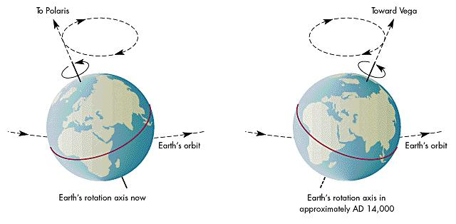
Figure 2: Precession of the Earth’s axis of rotation

The Apparent Motion of the Sun

Over the course of a year the Sun appears to move smoothly Eastwards from day to day, relative to the CS and the star background. This is due to the Earth’s orbital motion around the Sun; after one year the Earth returns to its starting point – having completed one full orbit anti-clockwise around the Sun – which has returned to the same point on the CS. This annual Solar motion explains why we see different constellations at different times of year – e.g. Taurus is seen in the sky on winter nights, but has disappeared by spring as the Sun then appears in that part of the sky.

The path followed by the Sun during the year is a great circle on the CS known as the Ecliptic. It is tilted with respect to the CE because the Earth’s rotation axis (and hence its equator) is tilted with respect to the plane of its orbit around the Sun (see figs. 3 and 4). The Ecliptic is inclined to the CE at angle of about $\text{23}\text{.}5^{∘}$; this angle is known as the obliquity of the ecliptic. The Ecliptic passes through a series of constellations that are referred to as the Zodiac, and comprise

Aries Taurus Gemini Cancer Leo Virgo
Libra Scorpius Sagittarius Capricornus Aquarius Pisces

(In fact the Ecliptic also passes through the constellation Ophiuchus, but this was not recognised by ancient astronomers as a Zodiac constellation). The word ‘Zodiac’ means ‘circle of animals’.

The Sun’s daily motion on the CS is quite significant. During the Earth’s orbital period of 365.25 days, the Sun works its way around ${\text{360}}^{∘}$ of the Ecliptic. This corresponds to about $1^{∘}$, or two solar diameters, per day.
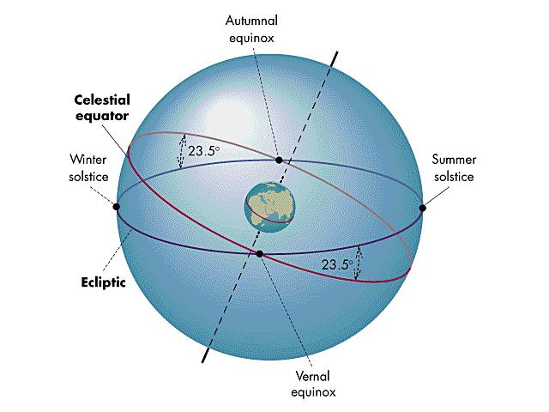

Figure 3: The Ecliptic and the Celestial Equator

The Seasons

As the Sun moves along the Ecliptic, it changes its distance from the CE. Consequently, the maximum altitude reached by the Sun as it crosses the observer’s Meridian each day varies throughout the year. It is this variation that is mainly responsible for the Earth’s seasons. When it is summer in the N. Hemisphere, the Sun is well above the CE – reaching a maximum elevation of $\text{23}\text{.}5^{∘}$ above it at the Summer Solstice (around Jun 21st) which – for the N. Hemisphere – is the longest day (because the Sun is above the horizon for a longer time than on any other day). Conversely during the N. Hemisphere winter the Sun reaches its minimum elevation of $\text{23}\text{.}5^{∘}$ below the CE at the Winter Solstice (around Dec 21st) which is the shortest day. We can understand this behaviour in terms of the tilt of the Earth’s axis to its orbital plane. In June the N. Hemisphere is tilted more towards the Sun and so receives more solar radiation. Hence the temperature is relatively high and the N. Hemisphere experiences summer. At the same time the S. Hemisphere is tilted away from the Sun and receives relatively less radiation, thus experiencing winter. Six months later, the tilt effect operates the other way (see fig. 4).

Because the orbit of the Earth is not exactly circular, there are small (2%) changes in the Earth-Sun distance through the year – with the closest approach (known as perihelion) in January. This only has a very small effect, however; by far the main cause of the seasons is the tilt of the Earth’s axis.

The point when the Sun crosses the CE, moving from the S. Hemisphere to the N. Hemisphere, is known as the Vernal (Spring) Equinox, around Mar 21st. On this date day and night are of equal length (‘Equinox’ = ‘Equal night’). Six months later (around Sep 21st) the Sun crosses the CE heading south, at the Autumnal Equinox; again on this date day and night are of equal length.

The Vernal Equinox provides an important reference point, known as the First Point of Aries. (In fact, due precession the First Point of Aries is no longer in Aries, but has shifted to Pisces). This point is important in celestial coordinate systems – as we see in the next lecture.

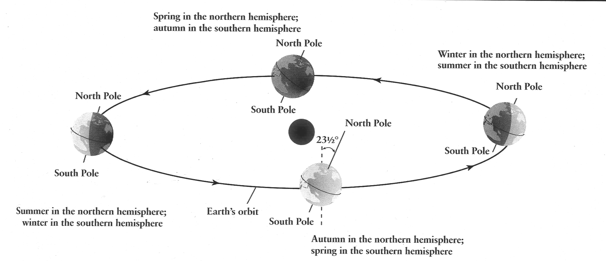

Figure 4: Tilt of the Earth’s axis of rotation and the Seasons

The seasonal variations in day and night are at their most extreme at the poles. The N. Pole experiences 6 months of continual daylight, from the Vernal Equinox until the Autumnal Equinox; meanwhile the S. Pole experiences 6 months of continual night. The situation is then reversed between the Autumnal Equinox and the following Vernal Equinox.

Apparent Motion of the Planets

The planets orbit the Sun roughly in the same plane as the Earth and, consequently, are always found in the sky close to the Ecliptic. Their angle relative to the Sun changes with time. Their own motion, combined with the motion of the Earth, causes them to move slowly against the star background, wandering through the constellations of the Zodiac. These motions became part of our culture through astrology, a superstition that originated in Babylon around 1000 BC. Babylonian astronomers supposed that the motions of the planets influenced the fate of kings and nations. Greek astronomers (e.g. Ptolemy) then adopted these beliefs and extended them to all individuals, with each person’s destiny being determined by their horoscope – a chart of the planetary positions along the Zodiac at the time of their birth.

Modern physics offers no plausible explanation for how the planets’ positions could influence the fate of an individual. The validity of astrology – assessed purely in statistical terms – has been tested many times without any significant effect being detected. Modern astronomers regard astrology as an irritating superstition left over from our sky-worshipping ancestors.

Because Mercury and Venus have orbits inside that of the Earth, their angle from the Sun is never too large (this is why e.g. Venus is also known as the ‘Morning’ or ‘Evening Star’). On the other hand Mars, Jupiter and Saturn (and Uranus, Neptune and Pluto) have orbits outside that of the Earth, and may be seen at any angle from the Sun – from $0^{∘}$ (behind the Sun) to ${\text{180}}^{∘}$ (opposite the Sun – when the planet is at opposition). The planets are especially bright during winter oppositions, since they are high in the South at midnight (when the Sun is low below the horizon in the North, and the sky is very dark). We return to the motion of the planets in Lectures 8 and 9.

