UNIVERSITY OF GLASGOW

Department of Physics and Astronomy Dr Martin Hendry
EXCOS 1X 2004-2005 Room 607, ext 5685
martin@astro.gla.ac.uk

Exploring the Sky

Course Website: http://www.astro.gla.ac.uk/users/martin/teaching/ets/index.html

(username: aone; password: aone)

Lecture 2: The Stars and Their Positions in the Sky

The Celestial Sphere

Observation of the night sky leads to the superficial impression that objects in the sky are ‘pinned’ to the inside surface of a sphere, with the Earth at its centre. This was basically the view developed by ancient astronomers, with the stars seen as ‘lamps hung from the vault of the heavens’. From any position on the Earth, only half of this sphere can be seen, the lower half being cut from view by the local horizon (fig. 1). Even in ancient times it was realised that this ‘sphere of the fixed stars’ had to be a very great distance away, since the star patterns showed no measurable parallax shift (fig. 2) when seen from different locations. (As we will discuss in later lectures, this fact also helped convince most ancient astronomers that the Earth was stationary, at the centre of the Universe. The nearest stars do show a parallax shift, but are so distant that it is a tiny fraction of a degree, and wasn’t detected until the 19th century). Although we now know that it is no more than an optical illusion, the idea of the stars (and indeed the planets) being attached to the inside surface of the Celestial Sphere is a rather useful way to visualise how things appear to us here on Earth.

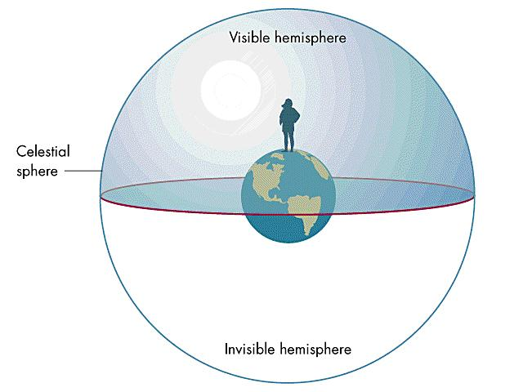
Figure 1: The Celestial Sphere

Diurnal Motion

During the period of one day (24 hours) how does the sky behave? We are conscious of a slow ‘drift’ of the Sun, Moon, planets and stars across the sky; using the reference points of NSEW provided by a magnetic compass we see that this motion is from East to West. Watching the sky carefully throughout the night quickly reveals a general pattern (see also fig. 3):
- Stars rise in the East, reach their maximum height above the horizon in the South – along the North-South line, known as the Meridian – and then set in the West
- The further East of South a star rises, the higher its maximum height above the horizon
- Some stars are always above the horizon as seen from Glasgow (although in day time they aren’t seen because the Sun is too bright). Other stars are never above the horizon
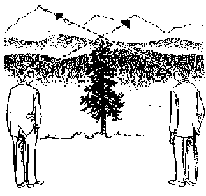
The apparent daily (or diurnal ) motion of celestial objects is due to the rotation of the Earth, about an axis through the North and South Poles. The North Celestial Pole (NCP) is the projection of the rotation axis from the North Pole onto the Celestial Sphere; it is the point on the sky around which all the celestial objects seem to revolve. The Pole Star or Polaris lies very close to the NCP, so finding the Pole Star in the sky is a very good way to find the direction of North. (In fact, the Pole Star is a much better indicator of North than a magnetic compass, since the Earth’s Magnetic North Pole is not actually at the North Pole of the Earth).
Figure 2: The effect of parallax. A and B line up the tree with different mountains because they are seeing it along different lines of sight. No such parallax shift is seen when we look at e.g. the constellations from different countries; this tells us that the stars must be very far away

A

B

We can find the Pole Star easily by first finding the group of seven stars known as The Plough, part of the constellation of Ursa Major (the Great Bear). As seen from Glasgow, these seven stars are circumpolar – i.e. they never set. So, provided it is a dark, clear sky, the Plough should always be visible from Glasgow, no matter the time of year.

The two stars at the ‘cutting edge’ of the Plough are known as the ‘Pointers’ and point towards the Pole Star (see fig. 4), which is in the adjacent constellation of Ursa Minor (the Little Bear).

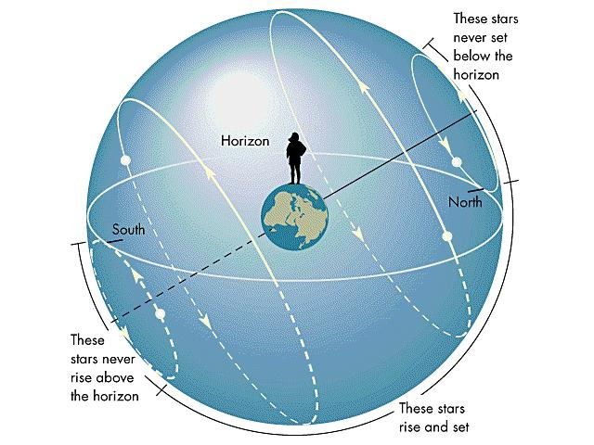
East
Meridian

Figure 3: Diurnal motion of different stars on the Celestial Sphere

The Stars from Different Locations

If we move our observing location on the surface of the Earth, the shapes and sizes of the constellations are unchanged, but their apparent position in the sky is altered. Suppose we move due North; eventually we will reach the North Pole, where the Pole Star will be directly overhead – i.e. all the stars would seem to rotate around us, neither rising nor setting. Suppose we travel next to the Equator; the NCP would now lie on the horizon, with the South Celestial Pole (SCP) also on the horizon in the opposite direction. (There isn’t a bright star close to the SCP in the sky, so it’s harder to find, but the constellation Crux Australis, or Southern Cross, points to the SCP). At the Equator, the stars would rise and set vertically. There is a pattern emerging here:

North Pole = latitude ${\text{90}}^{∘}$ = altitude of the Pole Star
South Pole = latitude $0^{∘}$ = altitude of the Pole Star

In general, for an observer anywhere north of the Equator, the altitude of the Pole Star above the horizon provides an immediate measure of the latitude of the observer. More precisely:

Altitude of the North Celestial Pole = Latitude of the Observer

Glasgow lies at a latitude of about ${\text{56}}^{∘}$; hence the NCP (and so the Pole Star) is about ${\text{56}}^{∘}$ above the horizon.

Estimating Angles on the Sky: A Matter of Degrees

In order to describe the positions of objects relative to each other in the sky, or to local landmarks, it is important to have a feel for angular measurements. First we need to know the basic definition that there are ${\text{360}}^{∘}$ around a circle. Some simple ‘rules of thumb’ can then help us (see fig. 5):

- The thickness of your thumb or index finger, held at arm’s length, covers (subtends ) about $1^{∘}$ on the sky. This is twice the angle subtended by the Full Moon
- The thickness of your fist, held at arm’s length, subtends about ${\text{10}}^{∘}$ on the sky (roughly the width of the Plough)
- The thickness of your outstretched hand, held at arm’s length, subtends about ${\text{18}}^{∘}$ on the sky (roughly the length of Orion’s body)

Next time you are outside on a clear night, practice estimating angular distances between stars on the sky, using these simple rules to guide you.

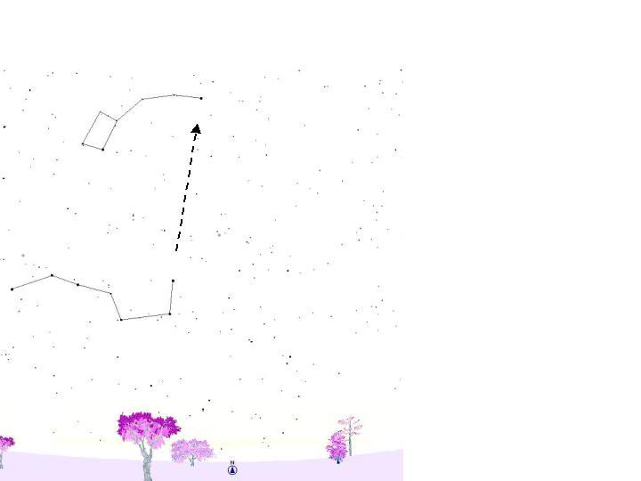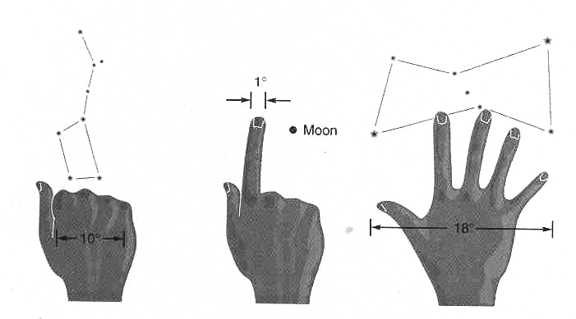

Figure 4: Using the Pointers to find the Pole Star Figure 5: Estimating angles on the sky

Early Celestial Maps and the Constellations

Many of the constellations have names that originated in the cultures of Mesopotamia, Babylonia and Ancient Greece. In most cases the ascribed names had some religious or mythical significance. Well known names (mainly of Greek origin, but later Latinised) include:

Orion, Taurus, Leo, Hercules, Pegasus and Cassiopeia

A number of other ancient cultures (e.g. Chinese, Hindu, North and Central American, African) also gave names to star groupings – often completely different (in both shape and legend) from those familiar today. The skies of Southern hemisphere were not mapped until Renaissance times, when navigators (e.g. Magellan, after whom the Magellanic Clouds – satellite galaxies of the Milky Way visible only in the Southern hemisphere – are named) went further afield from Europe and the Mediterranean. This revealed many stars which had never been visible to ancient Greek astronomers; these were assigned to new constellations, to help with navigation. Names include:

Argo Navis, Antlia, Telescopium, Microscopium, Sextans

Just as towns and cities are given names within a country’s borders, the brightest stars also were given individual names, usually originating from ancient Arabic cultures:

Betelgeuse, Rigel, Sirius, Capella, Vega, Achernar, Aldebaran, Arcturus

The stars are too numerous for all to be given individual names, and in any case the name gives no indication of which constellation a star belongs to. In 1603, Johann Bayer introduced a major change in the naming of stars with his star map Uranometria. In this map the constellation figures were beautifully drawn, but the stars were labelled by their constellation and by a Greek letter (α, β, γ, δ etc) denoting their apparent brightness: α = brightest star in the constellation, β = 2nd brightest star, and so on. Thus: Vega = α Lyrae; Rigel = β Orionis. (Nowadays, the constellation part of the name is usually abbreviated to three letters – e.g. Ori[on], Tau[rus], Her[cules] etc). Of course this scheme is limited by the number of letters in the alphabet; with the invention of the telescope many fainter stars were observed in the constellations – even those which appeared fairly ‘barren’ to the naked eye. After the supply of Greek letters was exhausted, additional stars were conveniently designated by numbers.

By universal consent, John Flamsteed’s British Catalogue – published in 1725 – became the accepted work for stellar identification. Towards the end of the 19th century, however, with developing technology (not just bigger telescopes but more importantly photography) fainter and fainter stars were being recorded and Flamsteed’s catalogue was by then totally inadequate. Another important milestone was the publication of the Henry Draper Catalogue, in 1890, containing about 250,000 stars. (e.g. Vega is also known as HD 172167). This catalogue is still used to identify stars today. Stars too faint to appear in the HD Catalogue are often identified by their celestial coordinates Right Ascension (RA) and Declination (Dec). [See later lectures for a precise definition, but roughly speaking RA and Dec are analogous to latitude and longitude on the Earth]. Much more recently, the advent of the Hubble Space Telescope has also led to the HST Guide Star Catalogue of about one million stars; this was compiled to ensure that HST could always be accurately pointed at whatever patch of sky it was observing, but also serves as a reference catalogue for other telescopes.

As the process of star mapping developed, comparisons between different catalogues revealed many inconsistencies in the layout and position of the constellations. In 1930 the International Astronomical Union (IAU) solved this problem by assigning official boundaries to the 88 designated constellations – dividing the sky completely into 88 zones. The apparent ‘straight’ boundaries were based on a regular grid of RA and Dec coordinates, used to measure stellar positions. (Note that these boundaries are curves on the sky; their straight representations on a flat star map are distorted in much the same way as the shapes and sizes of countries are distorted in an atlas of the world. The curvature of the sky can also been seen from looking at the curvature of the crescent Moon relative to the position of the Sun).

