University of Glasgow

Department of Physics and Astronomy

Galaxies II: Example Sheet 5
1)
Write down a general expression for the force of dynamical friction in the form
$$F_{\text{drag}} ≈ K {\left(\text{GM}\right)}^{a} v^{b} ρ^{c}$$
where $a$, $b$ and $c$ are constants and $K$ is dimensionless. Set up a system of three linear equations for $a$, $b$ and $c$, such that $F_{\text{drag}}$ has units of force $\left(\text{kg} {\text{ms}}^{\text{-2}}\right)$. Solve for $a$, $b$ and $c$ and show that this leads to the expression for $F_{\text{drag}}$ given in eq. (3.1) of your lecture notes, i.e.
$F_{\text{drag}} ≈ K \frac{{\left(\text{GM}\right)}^{2} ρ}{v^{2}}$ .
2)
Consider the dynamical friction acting on a globular cluster, of mass $M$, in a circular orbit in the halo of the Andromeda galaxy, M31. Suppose that the orbital velocity of the globular cluster is typical of the flat rotation curve observed in the outer part of M31. Let $ρ(r)$ denote the density of the dark matter halo of M31 at the radius, $r$, of the globular cluster.

- Show that the dynamical friction acting on the globular cluster is given by
$F_{\text{drag}} ≈ K \frac{{\text{GM}}^{2}}{4π r^{2}}$ .
- Write down an expression for the angular momentum, $L$, of the globular cluster and the torque, $L$, acting on it.
- Use the relation $\frac{\text{dL}}{\text{dt}}=τ$ to derive an expression for the time evolution of the orbital radius of the globular cluster, namely $\frac{\text{dr}}{\text{dt}}=−K\frac{\text{GM}}{4π r v}$, stating clearly any assumptions that you make.
- Solve this differential equation to obtain an expression for the cluster lifetime, $t_{\text{GC}}$, i.e. the timescale for the cluster to spiral from an initial radius, $r_{\text{init}}$, into the centre of M31:
$$t_{\text{GC}} = \frac{2π v r_{\text{init}}^{2}}{K GM}$$
- Invert this equation to find the orbital radius, $r_{\text{max}}$, of the most distant globular cluster that could have been captured within the estimated age, $t_{\text{Gal}}$, of M31.
[ Assume $M=5×{\text{10}}^{6} M_{\text{Sun}}$, $v=\text{250} {\text{kms}}^{\text{-1}}$, $t_{\text{Gal}}=\text{10} \text{Gyr}$, $K\text{\sim }\text{75}$ ]
- Can your expression for $r_{\text{max}}$ explain why there are no very massive (i.e. $M\text{\sim }{\text{10}}^{8} M_{\text{Sun}}$) globular clusters observed around M31?

The Large Magellanic Cloud, which has a mass of about $M=2×{\text{10}}^{\text{10}} M_{\text{Sun}}$, orbits the Milky Way at a distance of $r\text{\sim }\text{50} \text{kpc}$. Assuming that the Milky Way’s dark matter halo and flat rotation curve extend out to the distance of the LMC, estimate how long it will take for the LMC to spiral into the centre of the Milky Way, due to dynamical friction.
3)
[ Take $v=\text{220} {\text{kms}}^{\text{-1}}$ and $K\text{\sim }\text{25}$ for the LMC ]

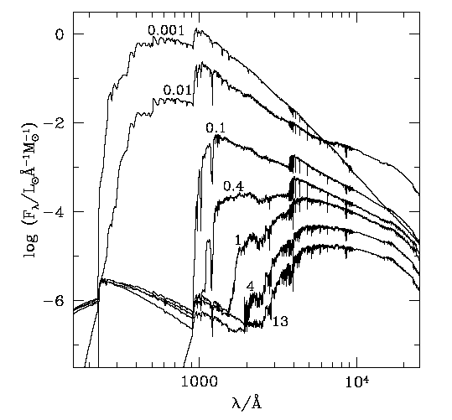
The figure on the right shows how the spectral energy distribution of a stellar population model evolves, from an age of ${\text{10}}^{6} \text{yr}$ to 13 Gyr. (The model begins with a single burst of star formation at time $t=0$).
- Explain the origin of the strong UV emission features in the uppermost spectrum, and why these decline sharply in the next three spectra.
- What is responsible for the near infra-red ‘bump’ in the 2nd spectrum
(age = 0.01 Gyr)?
4)

- What is responsible for the strong far-UV emission in the spectra for age 1 Gyr?
- Can you explain why the shape of the spectrum shows almost no evolution between the age of 4 Gyr and 13 Gyr? (Hint: consult the data in the table and figure below, reproduced from Sparke & Gallagher ‘Galaxies in the Universe’, to estimate the masses of stars leaving the Main Sequence when the age of the galaxy is between 4 and 13 Gyr. What do you notice about the post-MS evolutionary tracks of these stars?)
