Astrophysics ASTR3415
Homework Assignment No.4
(Due 11/23/05, 5pm)

- Two test masses are in a gravitational wave detector. One mass is initially at the origin and the other initially has coordinates $x=ε\text{cos}θ$, $y=ε\text{sin}θ$, $z=0$, where $ε,θ$ are constants. The masses are disturbed by a gravitational wave propagating in the z direction. It can be shown that the x and y components of the geodesic deviation of the two particles obey the differential equations
$$\frac{∂^{2}}{∂t^{2}}ξ^{x}=\frac{1}{2}ε\text{cos}θ\frac{∂^{2}}{∂t^{2}}h_{\text{xx}}+\frac{1}{2}ε\text{sin}θ\frac{∂^{2}}{∂t^{2}}h_{\text{xy}}$$
$$\frac{∂^{2}}{∂t^{2}}ξ^{y}=\frac{1}{2}ε\text{cos}θ\frac{∂^{2}}{∂t^{2}}h_{\text{xy}}−\frac{1}{2}ε\text{sin}θ\frac{∂^{2}}{∂t^{2}}h_{\text{xx}}$$

Verify that the following expressions are solutions to the above differential equations
$$ξ^{x}=ε\text{cos}θ+\frac{1}{2}ε\text{cos}θ B_{\text{xx}}\text{cos}ωt+\frac{1}{2}ε\text{sin}θ B_{\text{xy}}\text{cos}ωt$$
$$ξ^{y}=ε\text{sin}θ+\frac{1}{2}ε\text{cos}θ B_{\text{xy}}\text{cos}ωt−\frac{1}{2}ε\text{sin}θ B_{\text{xx}}\text{cos}ωt$$
where $h_{\text{xx}}=B_{\text{xx}}\text{cos}ωt$ and $h_{\text{xy}}=B_{\text{xy}}\text{cos}ωt$, and $B_{\text{xx}}$, $B_{\text{xy}}$ and $ω$ are constants.
[8]

- Consider the two cases: $B_{\text{xx}}=1, B_{\text{xy}}=0$ and $B_{\text{xy}}=1, B_{\text{xx}}=0$. For each case, take $ε=1$ and let $θ$ vary from 0 to $2π$ in the above equations. Plot the coordinates $\left(ξ^{x},ξ^{y}\right)$ for $ωt=0, ωt=π2, ωt=π,ωt=3π2$ and show that the behavior of the geodesic deviation follows the pattern of quadrupolar variations shown in Figure 12 of your notes. (You might find it easier to produce these plots using a computer package such as MAPLE, IDL or MATLAB. If you’re feeling particularly keen, you could make plots for a larger set of values of $ωt$ and join them together to make an animated gif). The two cases are known as the two polarization states of a gravitational wave.
[12]
- A binary neutron star system consists of two stars of mass $M$ in a circular orbit of coordinate radius $R$ around their common center of mass. The stars orbit with a frequency $f$. As stated in the notes (pg. 101 of Part 3), the metric perturbation produced by the orbital motion of the stars is
$$h_{\text{μν}}=\frac{2G}{c^{4}r}{\overset{¨}{I}}_{\text{μν}}$$
where the reduced quadrupole moment $I_{\text{μν}}$ satisfies
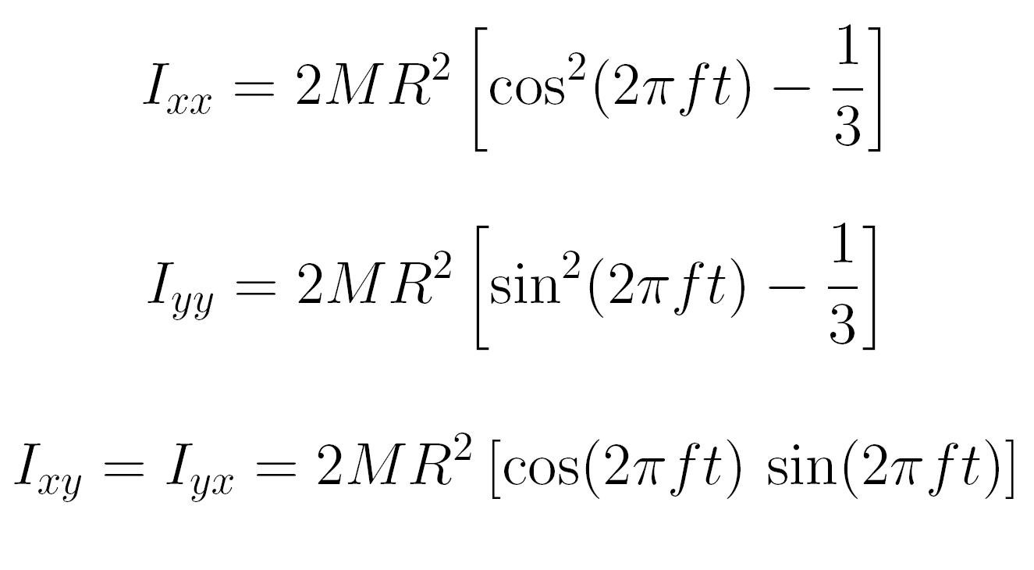
Show that
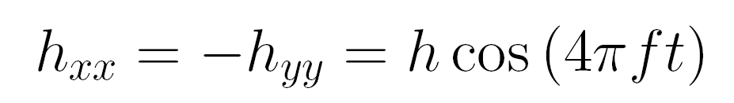
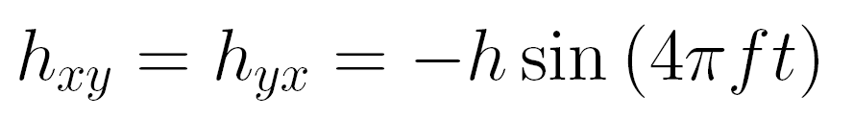
where
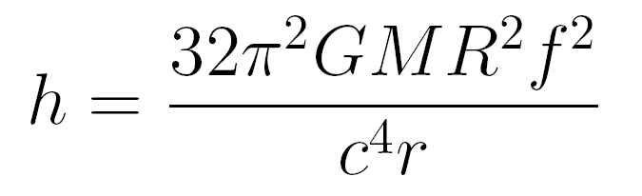
i.e. the binary system produces periodic gravitational waves with frequency equal to twice their orbital frequency.
[10]

Confirm that if we re-express h in more convenient units, then
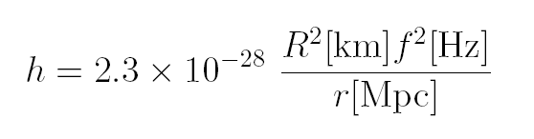
[5]
- Consider the Robertson-Walker metric
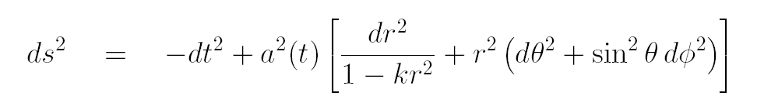
Suppose the curvature constant $k=3$. Show that, by re-scaling the coordinate radius $r$ and the scale factor $a(t)$ one may re-write the above expression for the invariant interval in a form with $k=1$.
[5]

Explain why there is no coordinate re-scaling that would allow the interval to be re-written in the form with $k=−1$. (This means that for a closed Universe one cannot define a new coordinate system in which the Universe appears to be open, and vice versa).
[3]

- Einstein’s introduction of a cosmological constant to preserve a static Universe required the solution
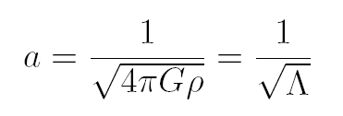
where the scale factor and density are constant (and assuming zero pressure).

Suppose the scale factor were to increase slightly? What effect would this have on the density of the Universe?
[2]
Consequently, what would be the effect on the second Friedmann equation (keeping $Λ$constant) ?
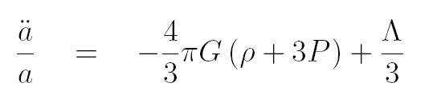
[2]
Hence, explain why this implies that Einstein’s static solution was unstable, rather like a pencil balanced on its point.
[3]

Total = 50 marks

